**NATIONAL INSTITUTE OF BUSINESS MANAGEMENT**

**HIGHER NATIONAL DIPLOMA IN SOFTWARE ENGINEERING**

**COURSEWORK**

**DATABASE MANAGEMENT 2**

**LEARNING MANAGEMENT SYSTEM (LMS)**

**SUBMITTED BY**

**MAHNDSE24.2F-022 K P AMOD MATHEESHA**

**MAHNDSE24.1F-024 T M NANAYAKKARA**

**MAHNDSE24.2F-013 P P J R PATABANDIGE**

**MAHNDSE24.2F-012 A A R WEHARI**

**Date of Submission: 2024-10-21**

# Declaration

“I certify that this project does not incorporate without acknowledgement, any material previously submitted for a Higher National Diploma in any institution and to the best of my knowledge and belief ,it does not contain any material previously published or written by another person or myself except where due reference is made in the text. I also hereby give consent for my project report, if accepted, to be made available for photocopying and for interlibrary loans, and for the title and summary to be made available to outside organizations”

**Index no Name Signature**

MAHNDSE24.2F-022 K P AMOD MATHEESHA ……………………….

MAHNDSE24.1F-024 T M NANAYAKKARA ……………………….

MAHNDSE24.2F-013 P P J R PATABANDIGE ……………………….

MAHNDSE24.2F-012 A A R WEHARI ……………………….

**Table of Contents**

**Table of Figures**

# Chapter 1

## **Introduction**

# Chapter 2

## **Database Design**

### **Logical Design**

### **Physical Design**

# Chapter 3

## **PL/SQL Programs for CRUD Operations**

### **Create Admin User in XE_System**

CREATE USER ADMIN IDENTIFIED BY ADMIN123

DEFAULT TABLESPACE users TEMPORARY TABLESPACE temp

QUOTA 20M ON users

ACCOUNT UNLOCK;

/

### **Grant All Privileges to Admin User**

GRANT ALL PRIVILEGES TO ADMIN;

### **Create LECTURER User in XE_System**

CREATE USER LECTURER IDENTIFIED BY LECTURER123

DEFAULT TABLESPACE users TEMPORARY TABLESPACE temp

QUOTA 20M ON users

ACCOUNT UNLOCK;

/

### **Create STUDENT User in XE_System**

CREATE USER STUDENT IDENTIFIED BY STUDENT123

DEFAULT TABLESPACE users TEMPORARY TABLESPACE temp

QUOTA 20M ON users

ACCOUNT UNLOCK;

/

### **Create User Role**

CREATE ROLE USER_ROLE;

### **Grant User Role and Connect Privileges to Student and Lecturer Users**

GRANT CONNECT TO USER_ROLE;

GRANT USER_ROLE TO STUDENT;

GRANT USER_ROLE TO LECTURER;

### **Connect ADMIN**

### **Connect LECTURER**

### **Connect STUDENT**

### **CREATE** **departments TABLE**

CREATE TABLE departments (

department_id NUMBER PRIMARY KEY,

department_name VARCHAR2(100) NOT NULL,

created_at TIMESTAMP DEFAULT CURRENT_TIMESTAMP

);

### **Insert Records into departments Table**

INSERT INTO departments (department_id, department_name) VALUES (1, 'School of Computing');

INSERT INTO departments (department_id, department_name) VALUES (2, 'School of Business');

INSERT INTO departments (department_id, department_name) VALUES (3, 'School of Engineering');

INSERT INTO departments (department_id, department_name) VALUES (4, 'School of Language');

INSERT INTO departments (department_id, department_name) VALUES (5, 'School of Humanities');

### **Retrieve All Records from departments Table**

SELECT * FROM departments;

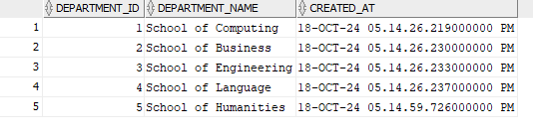

### **CREATE** **lecturers TABLE**

CREATE TABLE lecturers (

lecturer_id NUMBER PRIMARY KEY,

first_name VARCHAR2(50) NOT NULL,

last_name VARCHAR2(50),

email VARCHAR2(100) UNIQUE NOT NULL,

phone_number VARCHAR2(15) NOT NULL,

department_id NUMBER,

hire_date DATE NOT NULL ,

salary NUMBER CHECK (salary > 0),

status VARCHAR2(20) DEFAULT 'Active' CHECK (status IN ('Active','Retired','Resigned')),

FOREIGN KEY (department_id) REFERENCES departments (department_id)

);

### **Insert Records into lecturers** **Table**

INSERT INTO lecturers (lecturer_id, first_name, last_name, email, phone_number, department_id, hire_date, salary, status)

VALUES (1, 'Nimal', 'Perera', 'nimal.perera@schoolofcomputing.edu', '0711234567', 1, TO_DATE('2020-01-15', 'YYYY-MM-DD'), 80000, 'Active');

INSERT INTO lecturers (lecturer_id, first_name, last_name, email, phone_number, department_id, hire_date, salary, status)

VALUES (2, 'Saman', 'Silva', 'saman.silva@schoolofbusiness.edu', '0777654321', 2, TO_DATE('2018-03-10', 'YYYY-MM-DD'), 75000, 'Active');

INSERT INTO lecturers (lecturer_id, first_name, last_name, email, phone_number, department_id, hire_date, salary, status)

VALUES (3, 'Kamal', 'Fernando', 'kamal.fernando@schoolofengineering.edu', '0723456789', 3, TO_DATE('2019-08-25', 'YYYY-MM-DD'), 90000, 'Retired');

INSERT INTO lecturers (lecturer_id, first_name, last_name, email, phone_number, department_id, hire_date, salary, status)

VALUES (4, 'Sunil', 'Jayasinghe', 'sunil.jayasinghe@schooloflanguage.edu', '0709876543', 4, TO_DATE('2021-06-05', 'YYYY-MM-DD'), 60000, 'Active');

INSERT INTO lecturers (lecturer_id, first_name, last_name, email, phone_number, department_id, hire_date, salary, status)

VALUES (5, 'Ruwan', 'Dias', 'ruwan.dias@schoolofhumanities.edu', '0751237894', 5, TO_DATE('2017-12-01', 'YYYY-MM-DD'), 85000, 'Resigned');

INSERT INTO lecturers (lecturer_id, first_name, last_name, email, phone_number, department_id, hire_date, salary, status)

VALUES (6, 'Anura', 'Kumara', 'anura.kumara@schoolofcomputing.edu', '0765432123', 1, TO_DATE('2022-02-20', 'YYYY-MM-DD'), 72000, 'Active');

INSERT INTO lecturers (lecturer_id, first_name, last_name, email, phone_number, department_id, hire_date, salary, status)

VALUES (7, 'Chamara', 'Senanayake', 'chamara.senanayake@schoolofbusiness.edu', '0719876543', 2, TO_DATE('2016-09-18', 'YYYY-MM-DD'), 78000, 'Active');

INSERT INTO lecturers (lecturer_id, first_name, last_name, email, phone_number, department_id, hire_date, salary, status)

VALUES (8, 'Lakmal', 'Wijesinghe', 'lakmal.wijesinghe@schoolofengineering.edu', '0742345678', 3, TO_DATE('2020-05-12', 'YYYY-MM-DD'), 82000, 'Active');

INSERT INTO lecturers (lecturer_id, first_name, last_name, email, phone_number, department_id, hire_date, salary, status)

VALUES (9, 'Gayan', 'Weerasinghe', 'gayan.weerasinghe@schooloflanguage.edu', '0773219876', 4, TO_DATE('2021-11-23', 'YYYY-MM-DD'), 61000, 'Active');

INSERT INTO lecturers (lecturer_id, first_name, last_name, email, phone_number, department_id, hire_date, salary, status)

VALUES (10, 'Priyantha', 'Rajapaksa', 'priyantha.rajapaksa@schoolofhumanities.edu', '0756789123', 5, TO_DATE('2019-07-30', 'YYYY-MM-DD'), 86000, 'Active');

### **Retrieve All Records from lecturers Table**

SELECT * FROM lecturers;

### **CREATE** **courses TABLE**

CREATE TABLE courses (

course_id NUMBER PRIMARY KEY,

course_name VARCHAR2(100) UNIQUE NOT NULL,

department_id NUMBER NOT NULL,

description VARCHAR2(200),

credits NUMBER NOT NULL CHECK (credits > 0),

start_date DATE NOT NULL,

end_date DATE,

status VARCHAR2(20) DEFAULT 'Active' CHECK (status IN ('Active', 'Inactive', 'Completed')),

created_by NUMBER,

created_at TIMESTAMP DEFAULT CURRENT_TIMESTAMP,

FOREIGN KEY (department_id) REFERENCES departments (department_id),

FOREIGN KEY (created_by) REFERENCES lecturers (lecturer_id),

CHECK (end_date > start_date)

);

### **Insert Records into courses** **Table**

INSERT INTO courses (course_id, course_name, department_id, description, credits, start_date, end_date, created_by) VALUES

(1, 'Diploma in Software Engineering ', 1, 'This program introduces students to the fundamentals of programming', 40, TO_DATE('2024-01-10', 'YYYY-MM-DD'), TO_DATE('2025-01-15', 'YYYY-MM-DD'), 3);

INSERT INTO courses (course_id, course_name, department_id, description, credits, start_date, end_date, created_by) VALUES

(2, 'Higher National Diploma in Software Engineering ', 1, 'This program introduces students to the advances of programming', 45, TO_DATE('2024-05-10', 'YYYY-MM-DD'), TO_DATE('2025-05-15', 'YYYY-MM-DD'), 3);

INSERT INTO courses (course_id, course_name, department_id, description, credits, start_date, end_date, created_by) VALUES

(3, 'Advanced Diploma in Business Management', 2, 'This program introduces students to the fundamentals of Business', 30, TO_DATE('2024-01-10', 'YYYY-MM-DD'), TO_DATE('2025-01-15', 'YYYY-MM-DD'), 3);

INSERT INTO courses (course_id, course_name, department_id, description, credits, start_date, end_date, created_by) VALUES

(4, 'Higher National Diploma in Business Management', 2, 'This program introduces students to the advances of Business', 35, TO_DATE('2024-05-10', 'YYYY-MM-DD'), TO_DATE('2025-05-15', 'YYYY-MM-DD'), 3);

INSERT INTO courses (course_id, course_name, department_id, description, credits, start_date, end_date, created_by) VALUES

(5, 'Diploma in English', 4, 'This program introduces students to the English', 20, TO_DATE('2024-05-10', 'YYYY-MM-DD'), TO_DATE('2025-11-15', 'YYYY-MM-DD'), 3);

INSERT INTO courses (course_id, course_name, department_id, description, credits, start_date, end_date, created_by) VALUES

(6, 'Higher National Diploma in Network Engineering', 1, 'This program introduces students to the fundamentals of Network', 40, TO_DATE('2024-08-10', 'YYYY-MM-DD'), TO_DATE('2025-08-15', 'YYYY-MM-DD'), 3);

### **Retrieve All Records from courses Table**

SELECT * FROM courses;

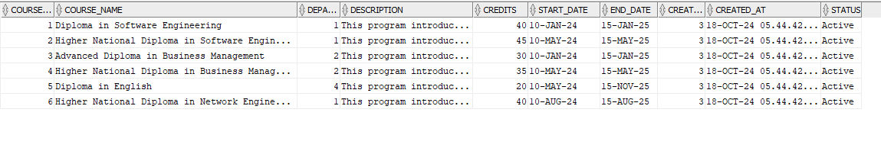

### **CREATE** **lessons TABLE**

CREATE TABLE lessons (

lesson_id NUMBER PRIMARY KEY,

course_id NUMBER,

lesson_name VARCHAR2(100) NOT NULL,

taught_by NUMBER NOT NULL,

status VARCHAR2(20) DEFAULT 'Active' CHECK (status IN ('Active','Inactive')),

created_by NUMBER NOT NULL,

created_at TIMESTAMP DEFAULT CURRENT_TIMESTAMP,

FOREIGN KEY (course_id) REFERENCES courses (course_id),

FOREIGN KEY (taught_by) REFERENCES lecturers (lecturer_id),

FOREIGN KEY (created_by) REFERENCES lecturers (lecturer_id)

);

### **Insert Records into lessons** **Table**

INSERT INTO lessons (lesson_id, course_id, lesson_name, taught_by, created_by) VALUES (1, 1, 'Introduction to Computer Science', 1, 3);

INSERT INTO lessons (lesson_id, course_id, lesson_name, taught_by, created_by) VALUES (2, 1, 'Mathematics for Computing', 2, 3);

INSERT INTO lessons (lesson_id, course_id, lesson_name, taught_by, created_by) VALUES (3, 1, 'Database Management Systems', 5, 3);

INSERT INTO lessons (lesson_id, course_id, lesson_name, taught_by, created_by) VALUES (4, 2, 'Object-Oriented Programming', 4, 3);

INSERT INTO lessons (lesson_id, course_id, lesson_name, taught_by, created_by) VALUES (5, 2, 'Web Development Basics', 6, 3);

INSERT INTO lessons (lesson_id, course_id, lesson_name, taught_by, created_by) VALUES (6, 2, 'Programming Fundamentals', 2, 3);

INSERT INTO lessons (lesson_id, course_id, lesson_name, taught_by, created_by) VALUES (7, 2, 'Electronics and Computer Architecture', 5, 3);

INSERT INTO lessons (lesson_id, course_id, lesson_name, taught_by, created_by) VALUES (8, 1, 'Computer Networks', 2, 3);

INSERT INTO lessons (lesson_id, course_id, lesson_name, taught_by, created_by) VALUES (9, 1, 'GUI Application Development', 4, 3);

INSERT INTO lessons (lesson_id, course_id, lesson_name, taught_by, created_by) VALUES (10, 1, 'Software Engineering', 5, 3);

INSERT INTO lessons (lesson_id, course_id, lesson_name, taught_by, created_by) VALUES (11, 2, 'Enterprise Application Development', 6, 3);

INSERT INTO lessons (lesson_id, course_id, lesson_name, taught_by, created_by) VALUES (12, 2, 'Operating Systems', 5, 3);

INSERT INTO lessons (lesson_id, course_id, lesson_name, taught_by, created_by) VALUES (13, 4, 'Financial Management', 7, 3);

INSERT INTO lessons (lesson_id, course_id, lesson_name, taught_by, created_by) VALUES (14, 4, 'Environmental Management', 8, 3);

INSERT INTO lessons (lesson_id, course_id, lesson_name, taught_by, created_by) VALUES (15, 4, 'Marketing Management', 8, 3);

INSERT INTO lessons (lesson_id, course_id, lesson_name, taught_by, created_by) VALUES (16, 4, 'Legal Environment', 9, 3);

INSERT INTO lessons (lesson_id, course_id, lesson_name, taught_by, created_by) VALUES (17, 4, 'Human Resource Management', 10, 3);

INSERT INTO lessons (lesson_id, course_id, lesson_name, taught_by, created_by) VALUES (18, 4, 'Project Management', 10, 3);

INSERT INTO lessons (lesson_id, course_id, lesson_name, taught_by, created_by) VALUES (19, 4, 'Operations Logistics Management', 9, 3);

### **Retrieve All Records from lessons Table**

SELECT * FROM lessons;

### **CREATE** **students TABLE**

CREATE TABLE students (

student_id NUMBER PRIMARY KEY,

first_name VARCHAR2(50) NOT NULL,

last_name VARCHAR2(50) NOT NULL,

email VARCHAR2(100) UNIQUE NOT NULL,

phone_number VARCHAR2(15) NOT NULL,

date_of_birth DATE ,

gender VARCHAR2(15) ,

address VARCHAR2(200),

status VARCHAR2(20) DEFAULT 'Active' CHECK (status IN ('Active','students','Suspended')),

created_at TIMESTAMP DEFAULT CURRENT_TIMESTAMP

);

### **Insert Records into students** **Table**

INSERT INTO students (student_id, first_name, last_name, email, phone_number, date_of_birth, gender, address)

VALUES (1, 'Amila', 'Perera', 'amilaperera@gmail.com', '0711234567', TO_DATE('2001-05-15', 'YYYY-MM-DD'), 'Male', '123, Colombo Road, Galle');

INSERT INTO students (student_id, first_name, last_name, email, phone_number, date_of_birth, gender, address)

VALUES (2, 'Kasuni', 'Samarasinghe', 'kasunisamarasinghe@gmail.com', '0722345678', TO_DATE('2000-08-25', 'YYYY-MM-DD'), 'Female', '45, Kandy Street, Kandy');

INSERT INTO students (student_id, first_name, last_name, email, phone_number, date_of_birth, gender, address)

VALUES (3, 'Chathura', 'Wijesinghe', 'chathurawijesinghe@gmail.com', '0713456789', TO_DATE('2002-12-10', 'YYYY-MM-DD'), 'Male', '78, Lake View, Kurunegala');

INSERT INTO students (student_id, first_name, last_name, email, phone_number, date_of_birth, gender, address)

VALUES (4, 'Nethmi', 'Jayasinghe', 'nethmijayasinghe@gmail.com', '0704567890', TO_DATE('2003-03-30', 'YYYY-MM-DD'), 'Female', '89, Beach Road, Matara');

INSERT INTO students (student_id, first_name, last_name, email, phone_number, date_of_birth, gender, address)

VALUES (5, 'Sajith', 'Fernando', 'sajithfernando@gmail.com', '0775678901', TO_DATE('2001-07-20', 'YYYY-MM-DD'), 'Male', '65, Temple Lane, Negombo');

INSERT INTO students (student_id, first_name, last_name, email, phone_number, date_of_birth, gender, address)

VALUES (6, 'Nimesha', 'Dissanayake', 'nimeshadissanayake@gmail.com', '0766789012', TO_DATE('2002-04-15', 'YYYY-MM-DD'), 'Female', '21, School Street, Galle');

INSERT INTO students (student_id, first_name, last_name, email, phone_number, date_of_birth, gender, address)

VALUES (7, 'Ravindu', 'Perera', 'ravinduperera@gmail.com', '0757890123', TO_DATE('2001-10-10', 'YYYY-MM-DD'), 'Male', '45, Main Road, Kandy');

INSERT INTO students (student_id, first_name, last_name, email, phone_number, date_of_birth, gender, address)

VALUES (8, 'Dilani', 'Gunasekara', 'dilanigunasekara@gmail.com', '0748901234', TO_DATE('2000-09-22', 'YYYY-MM-DD'), 'Female', '10, Hilltop, Nuwara Eliya');

INSERT INTO students (student_id, first_name, last_name, email, phone_number, date_of_birth, gender, address)

VALUES (9, 'Tharindu', 'Wijesooriya', 'tharinduwijesooriya@gmail.com', '0739012345', TO_DATE('2002-02-18', 'YYYY-MM-DD'), 'Male', '34, River View, Kegalle');

INSERT INTO students (student_id, first_name, last_name, email, phone_number, date_of_birth, gender, address)

VALUES (10, 'Ayesh', 'Rajapaksha', 'ayeshrajapaksha@gmail.com', '0720123456', TO_DATE('2001-06-30', 'YYYY-MM-DD'), 'Male', '88, Ocean Drive, Colombo');

INSERT INTO students (student_id, first_name, last_name, email, phone_number, date_of_birth, gender, address)

VALUES (11, 'Chami', 'Chandimal', 'chamichandimal@gmail.com', '0712345678', TO_DATE('2003-05-25', 'YYYY-MM-DD'), 'Female', '44, Park Avenue, Colombo');

INSERT INTO students (student_id, first_name, last_name, email, phone_number, date_of_birth, gender, address)

VALUES (12, 'Lakmal', 'Senevirathne', 'lakmalsenevirathne@gmail.com', '0703456789', TO_DATE('2001-01-01', 'YYYY-MM-DD'), 'Male', '56, Green Road, Anuradhapura');

INSERT INTO students (student_id, first_name, last_name, email, phone_number, date_of_birth, gender, address)

VALUES (13, 'Nimasha', 'Karunarathne', 'nimashakarunarathne@gmail.com', '0694567890', TO_DATE('2002-11-14', 'YYYY-MM-DD'), 'Female', '23, Forest Lane, Ratnapura');

INSERT INTO students (student_id, first_name, last_name, email, phone_number, date_of_birth, gender, address)

VALUES (14, 'Udara', 'Pathirana', 'udarapathirana@gmail.com', '0685678901', TO_DATE('2003-04-20', 'YYYY-MM-DD'), 'Male', '12, Seaside Avenue, Batticaloa');

INSERT INTO students (student_id, first_name, last_name, email, phone_number, date_of_birth, gender, address)

VALUES (15, 'Dhanuka', 'Silva', 'dhanukasilva@gmail.com', '0676789012', TO_DATE('2000-10-30', 'YYYY-MM-DD'), 'Male', '14, Mountain Road, Matale');

INSERT INTO students (student_id, first_name, last_name, email, phone_number, date_of_birth, gender, address)

VALUES (16, 'Shanika', 'Herath', 'shanikaherath@gmail.com', '0667890123', TO_DATE('2002-03-05', 'YYYY-MM-DD'), 'Female', '19, City Center, Jaffna');

INSERT INTO students (student_id, first_name, last_name, email, phone_number, date_of_birth, gender, address)

VALUES (17, 'Kamal', 'Fernando', 'kamalfernando@gmail.com', '0658901234', TO_DATE('2001-08-12', 'YYYY-MM-DD'), 'Male', '32, New Town, Colombo');

INSERT INTO students (student_id, first_name, last_name, email, phone_number, date_of_birth, gender, address)

VALUES (18, 'Gayan', 'Perera', 'gayanperera@gmail.com', '0649012345', TO_DATE('2003-06-18', 'YYYY-MM-DD'), 'Male', '27, Old Market, Galle');

INSERT INTO students (student_id, first_name, last_name, email, phone_number, date_of_birth, gender, address)

VALUES (19, 'Nihal', 'Bandara', 'nihalbandara@gmail.com', '0630123456', TO_DATE('2000-11-26', 'YYYY-MM-DD'), 'Male', '88, Lake Road, Colombo');

INSERT INTO students (student_id, first_name, last_name, email, phone_number, date_of_birth, gender, address)

VALUES (20, 'Thilini', 'Samarawickrama', 'thilinisanarawickrama@gmail.com', '0621234567', TO_DATE('2002-09-02', 'YYYY-MM-DD'), 'Female', '55, Hill Road, Galle');

INSERT INTO students (student_id, first_name, last_name, email, phone_number, date_of_birth, gender, address)

VALUES (21, 'Anushka', 'Fernando', 'anushkafernando@gmail.com', '0612345678', TO_DATE('2001-12-30', 'YYYY-MM-DD'), 'Female', '75, Church Street, Negombo');

INSERT INTO students (student_id, first_name, last_name, email, phone_number, date_of_birth, gender, address)

VALUES (22, 'Charitha', 'Abeysekera', 'charithaabeysekera@gmail.com', '0603456789', TO_DATE('2002-07-15', 'YYYY-MM-DD'), 'Male', '24, River Lane, Ratnapura');

INSERT INTO students (student_id, first_name, last_name, email, phone_number, date_of_birth, gender, address)

VALUES (23, 'Ruwangi', 'Senevirathne', 'ruwangisenevirathne@gmail.com', '0594567890', TO_DATE('2001-02-28', 'YYYY-MM-DD'), 'Female', '31, City View, Kandy');

INSERT INTO students (student_id, first_name, last_name, email, phone_number, date_of_birth, gender, address)

VALUES (24, 'Kanishka', 'Jayasinghe', 'kanishkajayasinghe@gmail.com', '0585678901', TO_DATE('2003-01-10', 'YYYY-MM-DD'), 'Male', '99, Coastal Road, Matara');

INSERT INTO students (student_id, first_name, last_name, email, phone_number, date_of_birth, gender, address)

VALUES (25, 'Lahiru', 'Kumarasinghe', 'lahirukumarasinghe@gmail.com', '0576789012', TO_DATE('2002-08-20', 'YYYY-MM-DD'), 'Male', '19, Bay Street, Colombo');

INSERT INTO students (student_id, first_name, last_name, email, phone_number, date_of_birth, gender, address)

VALUES (26, 'Janani', 'Rathnayake', 'jananirathnayake@gmail.com', '0567890123', TO_DATE('2001-03-16', 'YYYY-MM-DD'), 'Female', '28, Hill Side, Jaffna');

INSERT INTO students (student_id, first_name, last_name, email, phone_number, date_of_birth, gender, address)

VALUES (27, 'Sachin', 'Jayasuriya', 'sachinjayasuriya@gmail.com', '0558901234', TO_DATE('2000-04-22', 'YYYY-MM-DD'), 'Male', '90, Lake Road, Colombo');

INSERT INTO students (student_id, first_name, last_name, email, phone_number, date_of_birth, gender, address)

VALUES (28, 'Meghna', 'Perera', 'meghnaperera@gmail.com', '0549012345', TO_DATE('2003-07-11', 'YYYY-MM-DD'), 'Female', '45, City Hall, Kandy');

INSERT INTO students (student_id, first_name, last_name, email, phone_number, date_of_birth, gender, address)

VALUES (29, 'Vihanga', 'Jayasena', 'vihangajayasena@gmail.com', '0530123456', TO_DATE('2002-05-05', 'YYYY-MM-DD'), 'Male', '71, Coastal Road, Colombo');

INSERT INTO students (student_id, first_name, last_name, email, phone_number, date_of_birth, gender, address)

VALUES (30, 'Saman', 'Tharindu', 'samantaharindu@gmail.com', '0521234567', TO_DATE('2001-09-30', 'YYYY-MM-DD'), 'Male', '30, Market Street, Nuwara Eliya');

INSERT INTO students (student_id, first_name, last_name, email, phone_number, date_of_birth, gender, address)

VALUES (31, 'Sashini', 'Rajapakse', 'sashinirajapakse@gmail.com', '0512345678', TO_DATE('2000-10-15', 'YYYY-MM-DD'), 'Female', '67, Park Road, Colombo');

INSERT INTO students (student_id, first_name, last_name, email, phone_number, date_of_birth, gender, address)

VALUES (32, 'Harsha', 'Bandarage', 'harshabandara@gmail.com', '0503456789', TO_DATE('2001-11-11', 'YYYY-MM-DD'), 'Male', '90, Green Street, Anuradhapura');

INSERT INTO students (student_id, first_name, last_name, email, phone_number, date_of_birth, gender, address)

VALUES (33, 'Kavindu', 'Gunarathne', 'kavindugunarathne@gmail.com', '0494567890', TO_DATE('2002-08-28', 'YYYY-MM-DD'), 'Male', '32, Central Road, Colombo');

INSERT INTO students (student_id, first_name, last_name, email, phone_number, date_of_birth, gender, address)

VALUES (34, 'Manisha', 'Herath', 'manishaherath@gmail.com', '0485678901', TO_DATE('2003-02-14', 'YYYY-MM-DD'), 'Female', '26, Lake Road, Kandy');

INSERT INTO students (student_id, first_name, last_name, email, phone_number, date_of_birth, gender, address)

VALUES (35, 'Dulanjali', 'Fernando', 'dulanjalifernando@gmail.com', '0476789012', TO_DATE('2001-04-05', 'YYYY-MM-DD'), 'Female', '14, Hilltop, Colombo');

INSERT INTO students (student_id, first_name, last_name, email, phone_number, date_of_birth, gender, address)

VALUES (36, 'Dilshani', 'Seneviratne', 'dilshaniseneviratne@gmail.com', '0467890123', TO_DATE('2002-06-21', 'YYYY-MM-DD'), 'Female', '78, Sea View, Matara');

INSERT INTO students (student_id, first_name, last_name, email, phone_number, date_of_birth, gender, address)

VALUES (37, 'Namal', 'Perera', 'namalperera@gmail.com', '0458901234', TO_DATE('2001-09-12', 'YYYY-MM-DD'), 'Male', '33, Beach Road, Galle');

INSERT INTO students (student_id, first_name, last_name, email, phone_number, date_of_birth, gender, address)

VALUES (38, 'Suwanjana', 'Abeysinghe', 'suwanjanaabeysinghe@gmail.com', '0449012345', TO_DATE('2003-03-22', 'YYYY-MM-DD'), 'Female', '56, Temple Road, Colombo');

INSERT INTO students (student_id, first_name, last_name, email, phone_number, date_of_birth, gender, address)

VALUES (39, 'Hasith', 'Samarasekara', 'hasithsamarasekara@gmail.com', '0430123456', TO_DATE('2002-05-01', 'YYYY-MM-DD'), 'Male', '19, New Road, Ratnapura');

INSERT INTO students (student_id, first_name, last_name, email, phone_number, date_of_birth, gender, address)

VALUES (40, 'Chamila', 'Gunarathne', 'chamilagunarathne@gmail.com', '0421234567', TO_DATE('2000-07-29', 'YYYY-MM-DD'), 'Female', '12, Lake View, Kandy');

### **Retrieve All Records from students Table**

SELECT * FROM students;

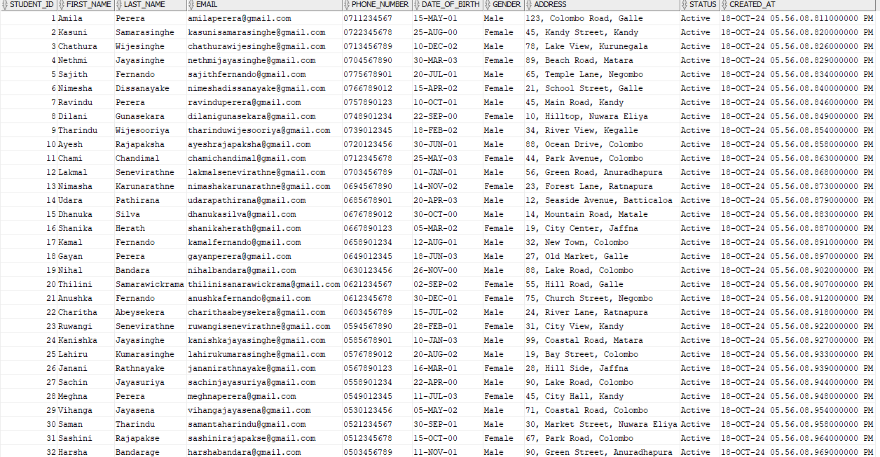

### **CREATE** **course_enrollments TABLE**

CREATE TABLE course_enrollments (

course_enrollments_id NUMBER PRIMARY KEY,

student_id NUMBER NOT NULL,

course_id NUMBER NOT NULL,

enrollement_date TIMESTAMP DEFAULT CURRENT_TIMESTAMP,

FOREIGN KEY (student_id) REFERENCES students (student_id),

FOREIGN KEY (course_id) REFERENCES courses (course_id)

);

### **Insert Records into course_enrollments** **Table**

INSERT INTO course_enrollments (course_enrollments_id, student_id, course_id) VALUES (1, 1, 1);

INSERT INTO course_enrollments (course_enrollments_id, student_id, course_id) VALUES (2, 2, 1);

INSERT INTO course_enrollments (course_enrollments_id, student_id, course_id) VALUES (3, 3, 1);

INSERT INTO course_enrollments (course_enrollments_id, student_id, course_id) VALUES (4, 4, 2);

INSERT INTO course_enrollments (course_enrollments_id, student_id, course_id) VALUES (5, 5, 2);

INSERT INTO course_enrollments (course_enrollments_id, student_id, course_id) VALUES (6, 6, 3);

INSERT INTO course_enrollments (course_enrollments_id, student_id, course_id) VALUES (7, 7, 3);

INSERT INTO course_enrollments (course_enrollments_id, student_id, course_id) VALUES (8, 8, 4);

INSERT INTO course_enrollments (course_enrollments_id, student_id, course_id) VALUES (9, 9, 4);

INSERT INTO course_enrollments (course_enrollments_id, student_id, course_id) VALUES (10, 10, 4);

INSERT INTO course_enrollments (course_enrollments_id, student_id, course_id) VALUES (11, 11, 1);

INSERT INTO course_enrollments (course_enrollments_id, student_id, course_id) VALUES (12, 12, 1);

INSERT INTO course_enrollments (course_enrollments_id, student_id, course_id) VALUES (13, 13, 2);

INSERT INTO course_enrollments (course_enrollments_id, student_id, course_id) VALUES (14, 14, 2);

INSERT INTO course_enrollments (course_enrollments_id, student_id, course_id) VALUES (15, 15, 3);

INSERT INTO course_enrollments (course_enrollments_id, student_id, course_id) VALUES (16, 16, 3);

INSERT INTO course_enrollments (course_enrollments_id, student_id, course_id) VALUES (17, 17, 4);

INSERT INTO course_enrollments (course_enrollments_id, student_id, course_id) VALUES (18, 18, 4);

INSERT INTO course_enrollments (course_enrollments_id, student_id, course_id) VALUES (19, 19, 1);

INSERT INTO course_enrollments (course_enrollments_id, student_id, course_id) VALUES (20, 20, 1);

INSERT INTO course_enrollments (course_enrollments_id, student_id, course_id) VALUES (21, 21, 5);

INSERT INTO course_enrollments (course_enrollments_id, student_id, course_id) VALUES (22, 22, 2);

INSERT INTO course_enrollments (course_enrollments_id, student_id, course_id) VALUES (23, 23, 3);

INSERT INTO course_enrollments (course_enrollments_id, student_id, course_id) VALUES (24, 24, 5);

INSERT INTO course_enrollments (course_enrollments_id, student_id, course_id) VALUES (25, 25, 4);

INSERT INTO course_enrollments (course_enrollments_id, student_id, course_id) VALUES (26, 26, 4);

INSERT INTO course_enrollments (course_enrollments_id, student_id, course_id) VALUES (27, 27, 1);

INSERT INTO course_enrollments (course_enrollments_id, student_id, course_id) VALUES (28, 28, 6);

INSERT INTO course_enrollments (course_enrollments_id, student_id, course_id) VALUES (29, 29, 2);

INSERT INTO course_enrollments (course_enrollments_id, student_id, course_id) VALUES (30, 30, 2);

INSERT INTO course_enrollments (course_enrollments_id, student_id, course_id) VALUES (31, 31, 3);

INSERT INTO course_enrollments (course_enrollments_id, student_id, course_id) VALUES (32, 32, 3);

INSERT INTO course_enrollments (course_enrollments_id, student_id, course_id) VALUES (33, 33, 4);

INSERT INTO course_enrollments (course_enrollments_id, student_id, course_id) VALUES (34, 34, 4);

INSERT INTO course_enrollments (course_enrollments_id, student_id, course_id) VALUES (35, 35, 1);

INSERT INTO course_enrollments (course_enrollments_id, student_id, course_id) VALUES (36, 36, 1);

INSERT INTO course_enrollments (course_enrollments_id, student_id, course_id) VALUES (37, 37, 2);

INSERT INTO course_enrollments (course_enrollments_id, student_id, course_id) VALUES (38, 38, 2);

INSERT INTO course_enrollments (course_enrollments_id, student_id, course_id) VALUES (39, 39, 3);

INSERT INTO course_enrollments (course_enrollments_id, student_id, course_id) VALUES (40, 40, 3);

### **Retrieve All Records from course_enrollments Table**

SELECT * FROM course_enrollments;

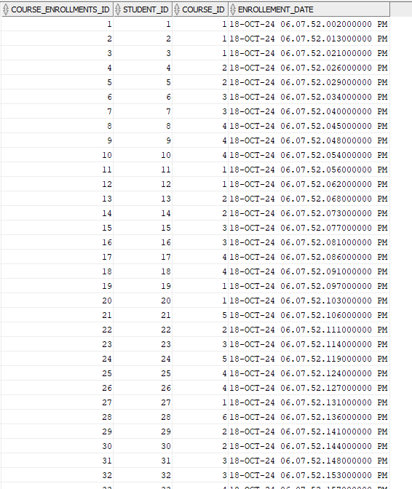

### **CREATE** **assignment TABLE**

CREATE TABLE assignment (

assignment_id NUMBER PRIMARY KEY,

assignment_title VARCHAR2(50) NOT NULL,

assignment_fiies VARCHAR2(50) NOT NULL,

lesson_id NUMBER NOT NULL,

post_date TIMESTAMP DEFAULT CURRENT_TIMESTAMP,

end_date DATE NOT NULL,

FOREIGN KEY (lesson_id) REFERENCES lessons (lesson_id)

);

### **Insert Records into assignment** **Table**

INSERT INTO assignment (assignment_id, assignment_title, assignment_fiies, lesson_id, end_date)

VALUES (1, 'Assignment 1', 'file1.pdf', 1, TO_DATE('2024-10-10', 'YYYY-MM-DD'));

### **Retrieve All Records from assignment Table**

SELECT * FROM assignment;

### **CREATE** **assignment_students TABLE**

CREATE TABLE assignment_students (

assignment_students_id NUMBER PRIMARY KEY,

assignment_id NUMBER NOT NULL,

student_id NUMBER NOT NULL,

submit_file VARCHAR2(200),

submissionDate TIMESTAMP,

status VARCHAR2(20),

grade VARCHAR2(20),

Feedback_on_Assessment VARCHAR2(100) ,

FOREIGN KEY (assignment_id) REFERENCES assignment (assignment_id),

FOREIGN KEY (student_id) REFERENCES students (student_id)

);

### **Insert Records into assignment_students** **Table**

INSERT INTO assignment_students (assignment_students_id, assignment_id, student_id, submit_file, status, submissionDate) VALUES

(1, 1, 1, 'assignment1_student1.docx', 'Submitted',SYSTIMESTAMP);

### **Retrieve All Records from assignment_students Table**

SELECT * FROM assignment_students;



### **CREATE** **assignment_students TABLE**

CREATE TABLE students_feedback (

feedback_id NUMBER PRIMARY KEY,

lesson_id NUMBER NOT NULL,

student_id NUMBER NOT NULL,

comments VARCHAR2(100) NOT NULL,

rating NUMBER NOT NULL CHECK (rating BETWEEN 1 AND 5),

post_date TIMESTAMP DEFAULT CURRENT_TIMESTAMP,

FOREIGN KEY (lesson_id) REFERENCES lessons (lesson_id),

FOREIGN KEY (student_id) REFERENCES students (student_id)

);

### **Insert Records into students_feedback** **Table**

INSERT INTO students_feedback (feedback_id, lesson_id, student_id, comments, rating) VALUES (1, 1, 1, 'The lesson was very informative and engaging.', 5);

### **Retrieve All Records from students_feedback Table**

SELECT * FROM students_feedback;



### **CREATE schedule TABLE**

CREATE TABLE schedule (

schedule_id NUMBER PRIMARY KEY,

lesson_id NUMBER NOT NULL,

schedule_date DATE NOT NULL,

lecture_hall VARCHAR2(50) NOT NULL,

FOREIGN KEY (lesson_id) REFERENCES lessons (lesson_id)

);



### **Insert Records into schedule Table**

INSERT INTO schedule (schedule_id, lesson_id, schedule_date, lecture_hall) VALUES (1, 1, TO_DATE('2024-10-22', 'YYYY-MM-DD'), 'Lecture Hall 01');

INSERT INTO schedule (schedule_id, lesson_id, schedule_date, lecture_hall) VALUES (2, 2, TO_DATE('2024-10-23', 'YYYY-MM-DD'), 'Lecture Hall 02');

INSERT INTO schedule (schedule_id, lesson_id, schedule_date, lecture_hall) VALUES (3, 1, TO_DATE('2024-10-24', 'YYYY-MM-DD'), 'Lecture Hall 03');

INSERT INTO schedule (schedule_id, lesson_id, schedule_date, lecture_hall) VALUES (4, 4, TO_DATE('2024-10-25', 'YYYY-MM-DD'), 'Lecture Hall 04');

INSERT INTO schedule (schedule_id, lesson_id, schedule_date, lecture_hall) VALUES (5, 1, TO_DATE('2024-10-26', 'YYYY-MM-DD'), 'Lecture Hall 05');

### **Retrieve All Records from schedule Table**

SELECT * FROM schedule;

### **Create Procedure to Insert Department Record**

CREATE OR REPLACE PROCEDURE insert_department (i_department_id IN NUMBER, i_department_name IN VARCHAR2) AS

BEGIN

INSERT INTO departments (department_id, department_name) VALUES (i_department_id, i_department_name);

EXCEPTION

WHEN OTHERS THEN

DBMS_OUTPUT.PUT_LINE('An error occurred ');

END ;

### **Insert Department Using Variables**

DECLARE

iu_department_id NUMBER := &department_id;

iu_department_name VARCHAR2(100) := '&department_name';

BEGIN

insert_department(iu_department_id, iu_department_name);

DBMS_OUTPUT.PUT_LINE('Department "' || iu_department_name || '" with ID ' || iu_department_id || ' has been successfully added.');

EXCEPTION

WHEN OTHERS THEN

DBMS_OUTPUT.PUT_LINE('Error inserting department ');

END;

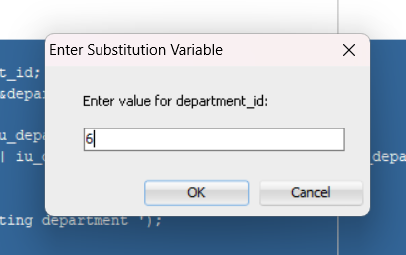

SELECT * FROM departments;



### **Create Procedure to update Department Record**

CREATE OR REPLACE PROCEDURE update_department (u_department_id IN NUMBER, u_department_name IN VARCHAR2) AS u_department_count NUMBER;

BEGIN

SELECT COUNT(*) INTO u_department_count FROM departments WHERE department_id = u_department_id;

IF u_department_count = 0 THEN

DBMS_OUTPUT.PUT_LINE('No department found ');

ELSE

UPDATE departments SET department_name = u_department_name WHERE department_id = u_department_id;

DBMS_OUTPUT.PUT_LINE('Updated');

END IF;

EXCEPTION

WHEN OTHERS THEN

DBMS_OUTPUT.PUT_LINE('An error occurred ');

END;

### **Update Department Using Variables**

SET SERVEROUTPUT ON;

DECLARE

v_department_id NUMBER := &department_id;

v_department_name VARCHAR2(100) := '&department_name';

BEGIN

update_department(v_department_id, v_department_name);

END;

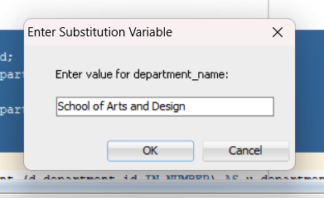

SELECT * FROM departments;



### **Create Procedure to delete Department Record**

CREATE OR REPLACE PROCEDURE delete_department (d_department_id IN NUMBER) AS u_department_count NUMBER;

BEGIN

SELECT COUNT(*) INTO u_department_count FROM departments WHERE department_id = d_department_id;

IF u_department_count = 0 THEN

DBMS_OUTPUT.PUT_LINE('No department found');

ELSE

DELETE FROM departments WHERE department_id = d_department_id;

DBMS_OUTPUT.PUT_LINE('Department deleted');

END IF;

EXCEPTION

WHEN OTHERS THEN

DBMS_OUTPUT.PUT_LINE('An error occurred ');

END;

### **Delete Department Using Variables**

SET SERVEROUTPUT ON;

DECLARE

v_department_id NUMBER := &department_id;

BEGIN

delete_department(v_department_id);

END;

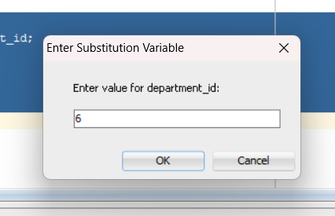

SELECT * FROM departments;

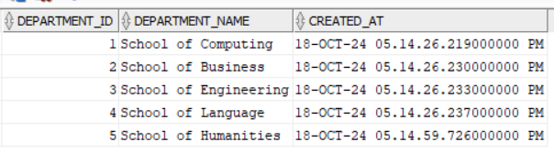

### **Create Procedure to insert lecturer** **Record**

CREATE OR REPLACE PROCEDURE insert_lecturer (p_lecturer_id IN NUMBER, p_first_name IN VARCHAR2, p_last_name IN VARCHAR2, p_email IN VARCHAR2,

p_phone_number IN VARCHAR2, p_department_id IN NUMBER,p_hire_date IN DATE,p_salary IN NUMBER) AS

BEGIN

INSERT INTO lecturers (lecturer_id, first_name, last_name, email, phone_number, department_id, hire_date, salary)

VALUES (p_lecturer_id, p_first_name, p_last_name, p_email, p_phone_number, p_department_id, p_hire_date, p_salary);

DBMS_OUTPUT.PUT_LINE('Successfully added');

EXCEPTION

WHEN OTHERS THEN

DBMS_OUTPUT.PUT_LINE('An error occurred');

END;

### **Insert Lecturer Using Variables**

SET SERVEROUTPUT ON;

DECLARE

v_lecturer_id NUMBER := &lecturer_id;

v_first_name VARCHAR2(50) := '&first_name';

v_last_name VARCHAR2(50) := '&last_name';

v_email VARCHAR2(100) := '&email';

v_phone_number VARCHAR2(15) := '&phone_number';

v_department_id NUMBER := &department_id;

v_hire_date DATE := TO_DATE('&hire_date', 'YYYY-MM-DD');

v_salary NUMBER := &salary;

BEGIN

insert_lecturer(v_lecturer_id, v_first_name, v_last_name, v_email, v_phone_number, v_department_id, v_hire_date, v_salary);

END;

/

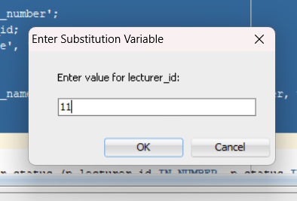

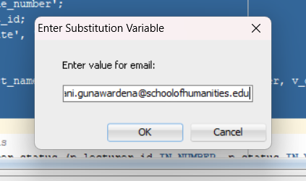

SELECT * FROM lecturers;



### **Create Procedure to update lecturer** **Record**

CREATE OR REPLACE PROCEDURE update_lecturer_status (p_lecturer_id IN NUMBER, p_status IN VARCHAR2) AS v_lecturer_count NUMBER;

BEGIN

SELECT COUNT(*) INTO v_lecturer_count FROM lecturers WHERE lecturer_id = p_lecturer_id;

IF v_lecturer_count = 0 THEN

DBMS_OUTPUT.PUT_LINE('No lecturer found');

ELSE

UPDATE lecturers SET status = p_status WHERE lecturer_id = p_lecturer_id;

DBMS_OUTPUT.PUT_LINE('Lecturer status updated ');

END IF;

EXCEPTION

WHEN OTHERS THEN

DBMS_OUTPUT.PUT_LINE('An error occurred');

END;

### **Update Lecturer Using Variables**

SET SERVEROUTPUT ON;

DECLARE

v_lecturer_id NUMBER := &lecturer_id;

v_status VARCHAR2(20) := '&status';

BEGIN

update_lecturer_status(v_lecturer_id, v_status);

END;

/

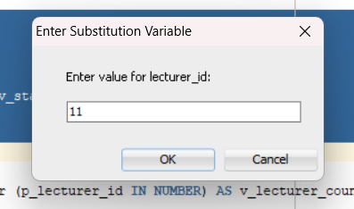

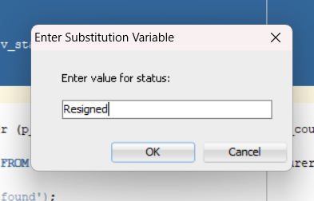

SELECT * FROM lecturers;



### **Create Procedure to delete lecturer** **Record**

CREATE OR REPLACE PROCEDURE delete_lecturer (p_lecturer_id IN NUMBER) AS v_lecturer_count NUMBER;

BEGIN

SELECT COUNT(*) INTO v_lecturer_count FROM lecturers WHERE lecturer_id = p_lecturer_id;

IF v_lecturer_count = 0 THEN

DBMS_OUTPUT.PUT_LINE('No lecturer found');

ELSE

DELETE FROM lecturers WHERE lecturer_id = p_lecturer_id;

DBMS_OUTPUT.PUT_LINE('Lecturer deleted');

END IF;

EXCEPTION

WHEN OTHERS THEN

DBMS_OUTPUT.PUT_LINE('An error occurred');

END;

### **Delete Lecturer Using Variable**

SET SERVEROUTPUT ON;

DECLARE

v_lecturer_id NUMBER := &lecturer_id;

BEGIN

delete_lecturer(v_lecturer_id);

END;

/

SELECT * FROM lecturers;



### **Create Procedure to insert course** **Record**

CREATE OR REPLACE PROCEDURE insert_course (p_course_id IN NUMBER, p_course_name IN VARCHAR2, p_department_id IN NUMBER, p_description IN VARCHAR2, p_credits IN NUMBER,

p_start_date IN DATE, p_end_date IN DATE, p_created_by IN NUMBER) AS

BEGIN

INSERT INTO courses (course_id, course_name, department_id, description, credits, start_date, end_date, created_by)

VALUES (p_course_id, p_course_name, p_department_id, p_description, p_credits, p_start_date, p_end_date, p_created_by);

DBMS_OUTPUT.PUT_LINE('Course successfully added');

EXCEPTION

WHEN OTHERS THEN

DBMS_OUTPUT.PUT_LINE('An error occurred');

END;

### **Insert Course Using Variables**

SET SERVEROUTPUT ON;

DECLARE

v_course_id NUMBER := &course_id;

v_course_name VARCHAR2(100) := '&course_name';

v_department_id NUMBER := &department_id;

v_description VARCHAR2(200) := '&description';

v_credits NUMBER := &credits;

v_start_date DATE := TO_DATE('&start_date', 'YYYY-MM-DD');

v_end_date DATE := TO_DATE('&end_date', 'YYYY-MM-DD');

v_created_by NUMBER := &created_by;

BEGIN

insert_course(v_course_id, v_course_name, v_department_id, v_description, v_credits, v_start_date, v_end_date, v_created_by);

END;

SELECT * FROM courses;



### **Create Procedure to update course** **Record**

CREATE OR REPLACE PROCEDURE update_course (p_course_id IN NUMBER, p_course_name IN VARCHAR2, p_department_id IN NUMBER, p_description IN VARCHAR2,

p_credits IN NUMBER,p_start_date IN DATE, p_end_date IN DATE, p_status IN VARCHAR2) AS

BEGIN

UPDATE courses SET course_name = p_course_name, department_id = p_department_id, description = p_description, credits = p_credits,

start_date = p_start_date, end_date = p_end_date,status = p_status WHERE course_id = p_course_id;

IF SQL%ROWCOUNT = 0 THEN

DBMS_OUTPUT.PUT_LINE('No course found');

ELSE

DBMS_OUTPUT.PUT_LINE('Course successfully updated');

END IF;

EXCEPTION

WHEN OTHERS THEN

DBMS_OUTPUT.PUT_LINE('An error occurred');

END;

### **Update Course Using Variables**

SET SERVEROUTPUT ON;

DECLARE

v_course_id NUMBER := &course_id;

v_course_name VARCHAR2(100) := '&course_name';

v_department_id NUMBER := &department_id;

v_description VARCHAR2(200) := '&description';

v_credits NUMBER := &credits;

v_start_date DATE := TO_DATE('&start_date', 'YYYY-MM-DD');

v_end_date DATE := TO_DATE('&end_date', 'YYYY-MM-DD');

v_status VARCHAR2(20) := '&status';

BEGIN

update_course(v_course_id, v_course_name, v_department_id, v_description, v_credits, v_start_date, v_end_date, v_status);

END;

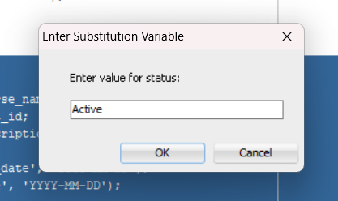

SELECT * FROM courses;



### **Create Procedure to delete course** **Record**

CREATE OR REPLACE PROCEDURE delete_course (p_course_id IN NUMBER) AS

BEGIN

DELETE FROM courses WHERE course_id = p_course_id;

IF SQL%ROWCOUNT = 0 THEN

DBMS_OUTPUT.PUT_LINE('No course found');

ELSE

DBMS_OUTPUT.PUT_LINE('Course successfully deleted');

END IF;

EXCEPTION

WHEN OTHERS THEN

DBMS_OUTPUT.PUT_LINE('An error occurred');

END;

### **Delete Course Using Variables**

SET SERVEROUTPUT ON;

DECLARE

v_course_id NUMBER := &course_id;

BEGIN

delete_course(v_course_id);

END;

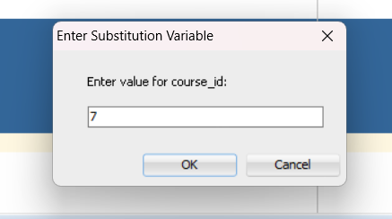

SELECT * FROM courses;



### **Create Procedure to insert lesson** **Record**

CREATE OR REPLACE PROCEDURE insert_lesson ( p_lesson_id IN NUMBER, p_course_id IN NUMBER, p_lesson_name IN VARCHAR2,

p_taught_by IN NUMBER, p_created_by IN NUMBER) AS

BEGIN

INSERT INTO lessons (lesson_id, course_id, lesson_name, taught_by, created_by)

VALUES (p_lesson_id, p_course_id, p_lesson_name, p_taught_by, p_created_by);

DBMS_OUTPUT.PUT_LINE('Lesson successfully added');

EXCEPTION

WHEN OTHERS THEN

DBMS_OUTPUT.PUT_LINE('An error occurred');

END;

### **Insert Lesson Using Variables**

SET SERVEROUTPUT ON;

DECLARE

v_lesson_id NUMBER := &lesson_id;

v_course_id NUMBER := &course_id;

v_lesson_name VARCHAR2(100) := '&lesson_name';

v_taught_by NUMBER := &taught_by;

v_created_by NUMBER := &created_by;

BEGIN

insert_lesson(v_lesson_id, v_course_id, v_lesson_name, v_taught_by, v_created_by);

END;

/

SELECT * FROM lessons;



### **Create Procedure to update lesson** **Record**

CREATE OR REPLACE PROCEDURE update_lesson (p_lesson_id IN NUMBER, p_lesson_name IN VARCHAR2,

p_status IN VARCHAR2,p_taught_by IN NUMBER) AS v_lesson_count NUMBER;

BEGIN

SELECT COUNT(*) INTO v_lesson_count FROM lessons WHERE lesson_id = p_lesson_id;

IF v_lesson_count = 0 THEN

DBMS_OUTPUT.PUT_LINE('No lesson found');

ELSE

UPDATE lessons SET lesson_name = p_lesson_name, status = p_status , taught_by = p_taught_by WHERE lesson_id = p_lesson_id;

DBMS_OUTPUT.PUT_LINE('Lesson with ID ' || p_lesson_id || ' has been updated.');

END IF;

EXCEPTION

WHEN OTHERS THEN

DBMS_OUTPUT.PUT_LINE('An error occurred');

END;

### **Update Lesson Using Variables**

SET SERVEROUTPUT ON;

DECLARE

v_lesson_id NUMBER := &lesson_id;

v_lesson_name VARCHAR2(100) := '&lesson_name';

v_status VARCHAR2(20) := '&status';

v_taught_by NUMBER := &taught_by;

BEGIN

update_lesson(v_lesson_id, v_lesson_name, v_status, v_taught_by);

END;

/

SELECT * FROM lessons;



### **Create Procedure to delete lesson** **Record**

CREATE OR REPLACE PROCEDURE delete_lesson ( p_lesson_id IN NUMBER) AS v_lesson_count NUMBER;

BEGIN

SELECT COUNT(*) INTO v_lesson_count FROM lessons WHERE lesson_id = p_lesson_id;

IF v_lesson_count = 0 THEN

DBMS_OUTPUT.PUT_LINE('No lesson found');

ELSE

DELETE FROM lessons WHERE lesson_id = p_lesson_id;

DBMS_OUTPUT.PUT_LINE('Lesson deleted.');

END IF;

EXCEPTION

WHEN OTHERS THEN

DBMS_OUTPUT.PUT_LINE('An error occurred');

END;

### **Delete Lesson Using Variables**

SET SERVEROUTPUT ON;

DECLARE

v_lesson_id NUMBER := &lesson_id;

BEGIN

delete_lesson(v_lesson_id);

END;

/

### **Trigger for Incrementing Student ID Before Insert**

CREATE OR REPLACE TRIGGER student_id_increment

BEFORE INSERT ON students

FOR EACH ROW

DECLARE

max_student_id NUMBER;

BEGIN

SELECT

CASE

WHEN MAX(student_id) IS NULL THEN 0 ELSE MAX(student_id)

END

INTO max_student_id FROM students;

:NEW.student_id := max_student_id + 1;

END student_id_increment;

### **Create Procedure to insert student** **Record**

CREATE OR REPLACE PROCEDURE insert_student (p_first_name IN VARCHAR2, p_last_name IN VARCHAR2, p_email IN VARCHAR2,

p_phone_number IN VARCHAR2, p_date_of_birth IN DATE, p_gender IN VARCHAR2, p_address IN VARCHAR2) AS

BEGIN

INSERT INTO students (first_name, last_name, email, phone_number, date_of_birth, gender, address)

VALUES (p_first_name, p_last_name, p_email, p_phone_number, p_date_of_birth, p_gender, p_address);

DBMS_OUTPUT.PUT_LINE('Student successfully added.');

EXCEPTION

WHEN OTHERS THEN

DBMS_OUTPUT.PUT_LINE('An error occurred');

END;

### **Insert Student Using Variables**

SET SERVEROUTPUT ON;

DECLARE

v_first_name VARCHAR2(50) := '&first_name';

v_last_name VARCHAR2(50) := '&last_name';

v_email VARCHAR2(100) := '&email';

v_phone_number VARCHAR2(15) := '&phone_number';

v_date_of_birth DATE := TO_DATE('&date_of_birth', 'YYYY-MM-DD');

v_gender VARCHAR2(15) := '&gender';

v_address VARCHAR2(200) := '&address';

BEGIN

insert_student(v_first_name, v_last_name, v_email, v_phone_number, v_date_of_birth, v_gender, v_address);

END;

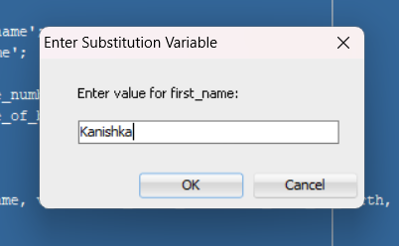

SELECT * FROM students;



### **Create Procedure to update student** **Record**

CREATE OR REPLACE PROCEDURE update_student ( p_student_id IN NUMBER, p_first_name IN VARCHAR2, p_last_name IN VARCHAR2, p_email IN VARCHAR2,

p_phone_number IN VARCHAR2, p_date_of_birth IN DATE, p_gender IN VARCHAR2, p_address IN VARCHAR2, p_status IN VARCHAR2) AS

v_student_count NUMBER;

BEGIN

SELECT COUNT(*) INTO v_student_count FROM students WHERE student_id = p_student_id;

IF v_student_count = 0 THEN

DBMS_OUTPUT.PUT_LINE('No student found');

ELSE

UPDATE students SET first_name = p_first_name, last_name = p_last_name, email = p_email, phone_number = p_phone_number,

date_of_birth = p_date_of_birth, gender = p_gender, address = p_address, status = p_status

WHERE student_id = p_student_id;

DBMS_OUTPUT.PUT_LINE('Student updated.');

END IF;

EXCEPTION

WHEN OTHERS THEN

DBMS_OUTPUT.PUT_LINE('An error occurred');

END;

### **Update Student Using Variables**

SET SERVEROUTPUT ON;

DECLARE

v_student_id NUMBER := &student_id;

v_first_name VARCHAR2(50) := '&first_name';

v_last_name VARCHAR2(50) := '&last_name';

v_email VARCHAR2(100) := '&email';

v_phone_number VARCHAR2(15) := '&phone_number';

v_date_of_birth DATE := TO_DATE('&date_of_birth', 'YYYY-MM-DD');

v_gender VARCHAR2(15) := '&gender';

v_address VARCHAR2(200) := '&address';

v_status VARCHAR2(20) := '&status';

BEGIN

update_student(v_student_id, v_first_name, v_last_name, v_email, v_phone_number, v_date_of_birth, v_gender, v_address, v_status);

END;

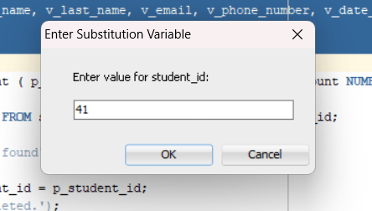

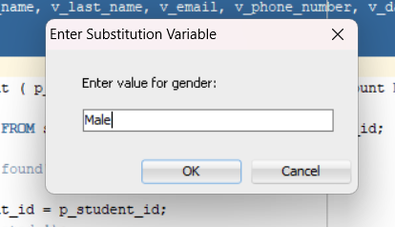

SELECT * FROM students;



### **Create Procedure to delete student** **Record**

CREATE OR REPLACE PROCEDURE delete_student ( p_student_id IN NUMBER) AS v_student_count NUMBER;

BEGIN

SELECT COUNT(*) INTO v_student_count FROM students WHERE student_id = p_student_id;

IF v_student_count = 0 THEN

DBMS_OUTPUT.PUT_LINE('No student found');

ELSE

DELETE FROM students WHERE student_id = p_student_id;

DBMS_OUTPUT.PUT_LINE('Student deleted.');

END IF;

EXCEPTION

WHEN OTHERS THEN

DBMS_OUTPUT.PUT_LINE('An error occurred ');

END;

### **Delete Student Using Variable**

SET SERVEROUTPUT ON;

DECLARE

v_student_id NUMBER := &student_id;

BEGIN

delete_student(v_student_id);

END;

### **Trigger for Incrementing Course Enrollments ID Before Insert**

CREATE OR REPLACE TRIGGER course_enrollments_id_increment

BEFORE INSERT ON course_enrollments

FOR EACH ROW

DECLARE

max_course_enrollments_id NUMBER;

BEGIN

SELECT

CASE

WHEN MAX(course_enrollments_id) IS NULL THEN 0 ELSE MAX(course_enrollments_id)

END

INTO max_course_enrollments_id FROM course_enrollments;

:NEW.course_enrollments_id := max_course_enrollments_id + 1;

END;

### **Create Procedure to insert course_enrollment** **Record**

CREATE OR REPLACE PROCEDURE insert_course_enrollment ( p_student_id IN NUMBER, p_course_id IN NUMBER) AS

BEGIN

INSERT INTO course_enrollments (student_id, course_id) VALUES (p_student_id, p_course_id);

DBMS_OUTPUT.PUT_LINE('Course enrollment added successfully.');

EXCEPTION

WHEN OTHERS THEN

DBMS_OUTPUT.PUT_LINE('An error occurred');

END ;

### **Enroll Student in Course Using Variables**

SET SERVEROUTPUT ON;

DECLARE

v_student_id NUMBER := &student_id;

v_course_id NUMBER := &course_id;

BEGIN

insert_course_enrollment(v_student_id, v_course_id);

END;

SELECT * FROM course_enrollments;



### **Create Procedure to update course_enrollment Record**

CREATE OR REPLACE PROCEDURE update_course_enrollment ( p_course_enrollments_id IN NUMBER, p_student_id IN NUMBER, p_course_id IN NUMBER) AS

v_enrollment_count NUMBER;

BEGIN

SELECT COUNT(*) INTO v_enrollment_count FROM course_enrollments WHERE course_enrollments_id = p_course_enrollments_id;

IF v_enrollment_count = 0 THEN

DBMS_OUTPUT.PUT_LINE('No course enrollment found');

ELSE

UPDATE course_enrollments SET student_id = p_student_id, course_id = p_course_id WHERE course_enrollments_id = p_course_enrollments_id;

DBMS_OUTPUT.PUT_LINE('Course enrollment updated');

END IF;

EXCEPTION

WHEN OTHERS THEN

DBMS_OUTPUT.PUT_LINE('An error occurred');

END;

### **Update Course Enrollment Using Variables**

SET SERVEROUTPUT ON;

DECLARE

v_course_enrollments_id NUMBER := &course_enrollments_id;

v_student_id NUMBER := &student_id;

v_course_id NUMBER := &course_id;

BEGIN

update_course_enrollment(v_course_enrollments_id, v_student_id, v_course_id);

END;

SELECT * FROM course_enrollments;



### **Create Procedure to delete course_enrollment Record**

CREATE OR REPLACE PROCEDURE delete_course_enrollment ( p_course_enrollments_id IN NUMBER) AS v_enrollment_count NUMBER;

BEGIN

SELECT COUNT(*) INTO v_enrollment_count FROM course_enrollments WHERE course_enrollments_id = p_course_enrollments_id;

IF v_enrollment_count = 0 THEN

DBMS_OUTPUT.PUT_LINE('No course enrollment found');

ELSE

DELETE FROM course_enrollments WHERE course_enrollments_id = p_course_enrollments_id;

DBMS_OUTPUT.PUT_LINE('Course enrollment deleted.');

END IF;

EXCEPTION

WHEN OTHERS THEN

DBMS_OUTPUT.PUT_LINE('An error occurred');

END;

### **Delete Course Enrollment Using Variable**

SET SERVEROUTPUT ON;

DECLARE

v_course_enrollments_id NUMBER := &course_enrollments_id;

BEGIN

delete_course_enrollment(v_course_enrollments_id);

END;

### **Trigger for Incrementing Assignment ID Before Insert**

CREATE OR REPLACE TRIGGER assignment_idincrement

BEFORE INSERT ON assignment

FOR EACH ROW

DECLARE

max_assignment_id NUMBER;

BEGIN

SELECT

CASE

WHEN MAX(assignment_id) IS NULL THEN 0 ELSE MAX(assignment_id)

END

INTO max_assignment_id FROM assignment;

:NEW.assignment_id := max_assignment_id + 1;

END;

/

### **Create Sequence for Assignment Students IDs**

CREATE SEQUENCE assignment_students_seq

START WITH 1

INCREMENT BY 1;

### **Trigger to Add Students to Assignment After Insertion**

CREATE OR REPLACE TRIGGER add_students_to_assignment

AFTER INSERT ON assignment

FOR EACH ROW

DECLARE

CURSOR student_cursor IS

SELECT ce.student_id FROM course_enrollments ce JOIN lessons l ON l.course_id = ce.course_id

WHERE l.lesson_id = :NEW.lesson_id;

BEGIN

FOR student_record IN student_cursor LOOP

INSERT INTO assignment_students (assignment_students_id, assignment_id, student_id, status)

VALUES (assignment_students_seq.NEXTVAL, :NEW.assignment_id, student_record.student_id, 'Not submitted');

END LOOP;

END;

/

### **Create Procedure to insert assignment** **Record**

CREATE OR REPLACE PROCEDURE insert_assignment (p_assignment_title IN VARCHAR2, p_assignment_fiies IN VARCHAR2, p_lesson_id IN NUMBER, p_end_date IN DATE) AS

BEGIN

INSERT INTO ADMIN.assignment (assignment_title,assignment_fiies,lesson_id,end_date) VALUES (p_assignment_title, p_assignment_fiies, p_lesson_id, p_end_date);

EXCEPTION

WHEN OTHERS THEN

DBMS_OUTPUT.PUT_LINE('Error occurred try agin');

END;

/



DELETE FROM assignment_students WHERE assignment_students_id = 1;



SELECT * FROM assignment_students;

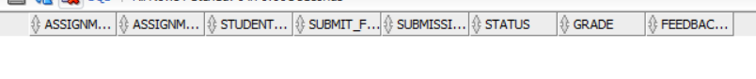

DELETE FROM assignment WHERE assignment_id = 1;

SELECT * FROM assignment;

### **Insert Assignment Using User Input and Variables**

SET SERVEROUTPUT ON;

DECLARE

v_assignment_title VARCHAR2(255);

v_assignment_fiies VARCHAR2(255);

v_lesson_id NUMBER;

v_end_date DATE;

BEGIN

DBMS_OUTPUT.PUT_LINE('Enter Assignment Title:');

v_assignment_title := '&assignment_title';

DBMS_OUTPUT.PUT_LINE('Enter Assignment File Name:');

v_assignment_fiies := '&assignment_fiies';

DBMS_OUTPUT.PUT_LINE('Enter Lesson ID:');

v_lesson_id := &lesson_id;

DBMS_OUTPUT.PUT_LINE('Enter End Date(YYYY-MM-DD):');

v_end_date := TO_DATE('&end_date','YYYY-MM-DD');

ADMIN.insert_assignment(v_assignment_title, v_assignment_fiies, v_lesson_id, v_end_date);

DBMS_OUTPUT.PUT_LINE('Assignment inserted successfully');

EXCEPTION

WHEN OTHERS THEN

DBMS_OUTPUT.PUT_LINE('Error occurred');

END;

/

SELECT * FROM assignment;

SELECT * FROM assignment_students;

### **Create Procedure to Submit Assignment for Student**

CREATE OR REPLACE PROCEDURE submit_assignment_student (p_assignment_id IN NUMBER,p_students_id IN NUMBER,p_submit_file IN VARCHAR2) AS

BEGIN

UPDATE ADMIN.assignment_students SET submit_file = p_submit_file, status = 'Submitted', submissionDate = SYSTIMESTAMP

WHERE assignment_id = p_assignment_id AND student_id = p_students_id;

DBMS_OUTPUT.PUT_LINE('Record updated successfully');

EXCEPTION

WHEN NO_DATA_FOUND THEN

DBMS_OUTPUT.PUT_LINE('No record found');

WHEN OTHERS THEN

DBMS_OUTPUT.PUT_LINE('Error');

END;

/

### **Submit Assignment for Student Using User Input and Variables**

SET SERVEROUTPUT ON;

DECLARE

v_assignment_id NUMBER;

v_students_id NUMBER;

v_submit_file VARCHAR2(255);

BEGIN

DBMS_OUTPUT.PUT_LINE('Enter Assignment ID:');

v_assignment_id := &assignment_id;

DBMS_OUTPUT.PUT_LINE('Enter Assignment Student ID:');

v_students_id := &students_id;

DBMS_OUTPUT.PUT_LINE('Enter Submit File Name:');

v_submit_file := '&submit_file';

ADMIN.submit_assignment_student(v_assignment_id, v_students_id, v_submit_file);

DBMS_OUTPUT.PUT_LINE('Assignment student record updated successfully.');

EXCEPTION

WHEN OTHERS THEN

DBMS_OUTPUT.PUT_LINE('Error occurred');

END;

/

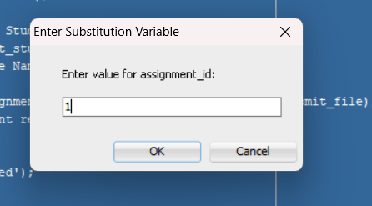

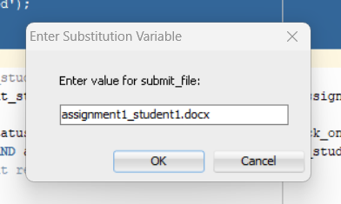

SELECT * FROM assignment_students;

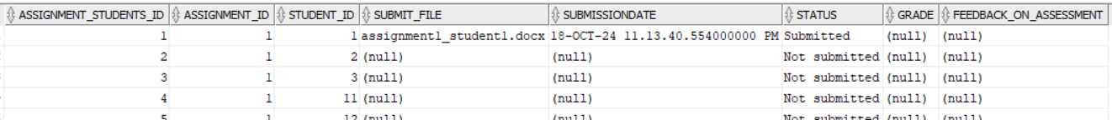

### **Create Procedure to Grade Student Assignment**

CREATE OR REPLACE PROCEDURE grade_assignment_student (p_assignment_id IN NUMBER,p_student_id IN NUMBER,p_grade IN VARCHAR2,p_feedback IN VARCHAR2) AS

BEGIN

UPDATE ADMIN.assignment_students SET status = 'Graded', grade = p_grade, Feedback_on_Assessment = p_feedback

WHERE assignment_id = p_assignment_id AND student_id = p_student_id;

DBMS_OUTPUT.PUT_LINE('Assignment student record graded successfully.');

EXCEPTION

WHEN NO_DATA_FOUND THEN

DBMS_OUTPUT.PUT_LINE('No record found');

WHEN OTHERS THEN

DBMS_OUTPUT.PUT_LINE('Error occurred');

END;

/

### **Grade Student Assignment Using User Input and Variables**

SET SERVEROUTPUT ON;

DECLARE

v_assignment_id NUMBER;

v_student_id NUMBER;

v_grade VARCHAR2(20);

v_feedback VARCHAR2(100);

BEGIN

DBMS_OUTPUT.PUT_LINE('Enter Assignment ID:');

v_assignment_id := &assignment_id;

DBMS_OUTPUT.PUT_LINE('Enter Assignment Student ID:');

v_student_id := &student_id;

DBMS_OUTPUT.PUT_LINE('Enter Grade:');

v_grade := '&grade';

DBMS_OUTPUT.PUT_LINE('Enter Feedback:');

v_feedback := '&feedback';

ADMIN.grade_assignment_student(v_assignment_id, v_student_id, v_grade, v_feedback);

DBMS_OUTPUT.PUT_LINE('Assignment student record updated successfully.');

EXCEPTION

WHEN OTHERS THEN

DBMS_OUTPUT.PUT_LINE('Error occurred.');

END;

/

SELECT * FROM assignment_students;



### **Trigger for Incrementing Feedback ID Before Insert**

CREATE OR REPLACE TRIGGER feedback_id_increment

BEFORE INSERT ON students_feedback

FOR EACH ROW

DECLARE

max_feedback_id NUMBER;

BEGIN

SELECT

CASE

WHEN MAX(feedback_id) IS NULL THEN 0 ELSE MAX(feedback_id)

END

INTO max_feedback_id FROM students_feedback;

:NEW.feedback_id := max_feedback_id + 1;

END;

/

### **Create Procedure to Insert Student Feedback**

CREATE OR REPLACE PROCEDURE insert_student_feedback (p_course_id IN NUMBER,p_student_id IN NUMBER,p_comments IN VARCHAR2,p_rating IN NUMBER) AS

v_count NUMBER;

BEGIN

SELECT COUNT(*) INTO v_count FROM course_enrollments WHERE student_id = p_student_id AND course_id = p_course_id;

IF v_count > 0 THEN

INSERT INTO students_feedback (lesson_id, student_id, comments, rating, post_date) VALUES (p_course_id, p_student_id, p_comments, p_rating, SYSTIMESTAMP);

DBMS_OUTPUT.PUT_LINE('Feedback inserted successfully.');

ELSE

DBMS_OUTPUT.PUT_LINE('The student is not related to the specified lesson');

END IF;

EXCEPTION

WHEN OTHERS THEN

DBMS_OUTPUT.PUT_LINE('Error occurred');

END;

/

### **Insert Student Lesson Feedback**

SET SERVEROUTPUT ON;

DECLARE

v_course_id NUMBER;

v_student_id NUMBER;

v_comments VARCHAR2(255);

v_rating NUMBER;

BEGIN

DBMS_OUTPUT.PUT_LINE('Enter Course ID:');

v_course_id := &course_id;

DBMS_OUTPUT.PUT_LINE('Enter Student ID:');

v_student_id := &student_id;

DBMS_OUTPUT.PUT_LINE('Enter Comments:');

v_comments := '&comments';

DBMS_OUTPUT.PUT_LINE('Enter Rating (1-5):');

v_rating := &rating;

ADMIN.insert_student_feedback(v_course_id, v_student_id, v_comments, v_rating);

EXCEPTION

WHEN OTHERS THEN

DBMS_OUTPUT.PUT_LINE('An error occurred: ' || SQLERRM);

END;

/

SELECT * FROM students_feedback;

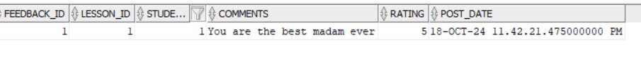

### **Insert Student Lesson Feedback with Invalid Student ID**

INSERT INTO students_feedback (lesson_id, student_id, comments, rating)

VALUES (1, 2, 'I enjoyed the interactive activities and practical examples.', 5);

INSERT INTO students_feedback (lesson_id, student_id, comments, rating)

VALUES (1, 11, 'Very detailed and helpful. I learned a lot from this lesson.', 4);

INSERT INTO students_feedback (lesson_id, student_id, comments, rating)

VALUES (1, 19, 'The lesson was engaging, but the lecture duration was too long.', 3);

### **Create Procedure to Retrieve Feedback by Lecturer**

CREATE OR REPLACE PROCEDURE get_feedback_by_lecturer (p_lecturer_id IN NUMBER) AS feedback_found BOOLEAN := FALSE;

BEGIN

FOR rec IN (SELECT l.lesson_name, sf.comments, sf.rating, sf.post_date FROM ADMIN.students_feedback sf JOIN lessons l ON sf.lesson_id = l.lesson_id

WHERE l.lesson_id IN (SELECT lesson_id FROM ADMIN.lessons WHERE taught_by = p_lecturer_id)) LOOP

DBMS_OUTPUT.PUT_LINE('Lesson: ' || rec.lesson_name );

DBMS_OUTPUT.PUT_LINE('Comment: ' || rec.comments );

DBMS_OUTPUT.PUT_LINE('Rating: ' || rec.rating );

DBMS_OUTPUT.PUT_LINE('Date: ' || rec.post_date );

DBMS_OUTPUT.PUT_LINE(' ');

feedback_found := TRUE;

END LOOP;

IF NOT feedback_found THEN

DBMS_OUTPUT.PUT_LINE('No feedback found');

END IF;

EXCEPTION

WHEN OTHERS THEN

DBMS_OUTPUT.PUT_LINE('An error occurred');

END get_feedback_by_lecturer;

/

### **Fetch Feedback by Lecturer ID**

SET SERVEROUTPUT ON;

DECLARE

v_lecturer_id NUMBER;

BEGIN

DBMS_OUTPUT.PUT_LINE('Enter Lecturer ID:');

v_lecturer_id := &lecturer_id;

ADMIN.get_feedback_by_lecturer(v_lecturer_id);

END;

/

### **Trigger to Increment Schedule ID Before Insert**

CREATE OR REPLACE TRIGGER schedule_id_increment

BEFORE INSERT ON schedule

FOR EACH ROW

DECLARE

max_schedule_id NUMBER;

BEGIN

SELECT

CASE

WHEN MAX(schedule_id) IS NULL THEN 0 ELSE MAX(schedule_id)

END

INTO max_schedule_id

FROM schedule;

:NEW.schedule_id := max_schedule_id + 1;

END;

/



### **Procedure to Add a Schedule**

CREATE OR REPLACE PROCEDURE add_schedule_proc(

p_lesson_id lessons.lesson_id%TYPE,

p_schedule_date schedule.schedule_date%TYPE,

p_lecture_hall schedule.lecture_hall%TYPE) IS

BEGIN

INSERT INTO schedule (lesson_id, schedule_date, lecture_hall)

VALUES (p_lesson_id, p_schedule_date, p_lecture_hall);

EXCEPTION

WHEN OTHERS THEN

DBMS_OUTPUT.PUT_LINE('Error');

END;

/



### **Execute Schedule Addition Procedure**

BEGIN

add_schedule_proc(1, TO_DATE('2024-10-26', 'YYYY-MM-DD'), 'Lecture Hall 05');

END;

/



select * from schedule;

### **Display Lesson and Schedule Details Using Cursor**

SET SERVEROUTPUT ON;

DECLARE

CURSOR schedule_cursor IS

SELECT schedule_id, lesson_id, schedule_date, lecture_hall FROM schedule;

schedule_rec schedule_cursor%ROWTYPE;

lesson_name lessons.lesson_name%TYPE;

BEGIN

FOR schedule_rec IN schedule_cursor LOOP

SELECT lesson_name INTO lesson_name FROM lessons WHERE lesson_id = schedule_rec.lesson_id;

DBMS_OUTPUT.PUT_LINE('Lesson Name: ' || lesson_name);

DBMS_OUTPUT.PUT_LINE('Schedule Date: ' || TO_CHAR(schedule_rec.schedule_date, 'DD-MON-YYYY'));

DBMS_OUTPUT.PUT_LINE('Lecture Hall: ' || schedule_rec.lecture_hall);

DBMS_OUTPUT.PUT_LINE(' ');

END LOOP;

END;

/

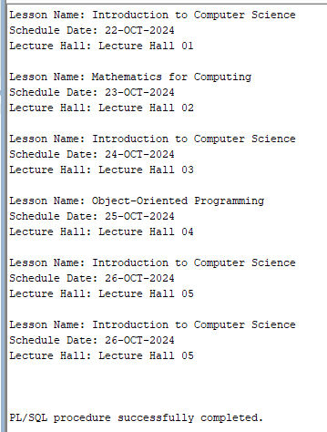

### **Assign User Role Permissions to Students and Lecturers**

GRANT SELECT ON ADMIN.assignment TO USER_ROLE;

GRANT SELECT ON ADMIN.assignment_students TO USER_ROLE;

GRANT USER_ROLE TO STUDENT;

GRANT USER_ROLE TO LECTURER;

### **Grant DML and Execute Permissions to Lecturers**

GRANT INSERT,DELETE,UPDATE ON ADMIN.assignment TO LECTURER;

GRANT UPDATE ON ADMIN.assignment_students TO LECTURER;

GRANT EXECUTE ON ADMIN.insert_assignment TO LECTURER;

GRANT EXECUTE ON ADMIN.grade_assignment_student TO LECTURER;

GRANT EXECUTE ON ADMIN.get_feedback_by_lecturer TO LECTURER;

### **Grant Update and Execute Permissions to Students**

GRANT UPDATE (submit_file, status, submissionDate) ON ADMIN.assignment_students TO STUDENT;

GRANT EXECUTE ON ADMIN.submit_assignment_student TO STUDENT;

GRANT EXECUTE ON ADMIN.insert_student_feedback TO STUDENT;

### **Number of lessons and courses Offered by Each Department**

SELECT d.department_id, d.department_name, COUNT(DISTINCT c.course_id) AS total_courses, COUNT(l.lesson_id) AS total_lessons

FROM departments d LEFT JOIN courses c ON d.department_id = c.department_id

LEFT JOIN lessons l ON c.course_id = l.course_id

GROUP BY d.department_id, d.department_name ORDER BY d.department_name;

### **Lecturers Who Have Taught More Than two Lessons**

SELECT l.lecturer_id, l.first_name, l.last_name, COUNT(ls.lesson_id) AS lessons_taught

FROM lecturers l INNER JOIN lessons ls ON l.lecturer_id = ls.taught_by

GROUP BY l.lecturer_id, l.first_name, l.last_name

HAVING COUNT(ls.lesson_id) > 2

ORDER BY lessons_taught DESC;

### **All Students Enrolled in Diploma in Software Engineering**

SELECT s.student_id, s.first_name, s.last_name, s.email

FROM students s INNER JOIN course_enrollments ce ON s.student_id = ce.student_id

INNER JOIN courses c ON ce.course_id = c.course_id

WHERE c.course_name = 'Diploma in Software Engineering ';

### **All Assignments Due in Next 7 Days**

INSERT INTO assignment (assignment_title, assignment_fiies, lesson_id, end_date)

VALUES (' Database Management System Assignment', 'dbms_assignment.docx', 3, TO_DATE('2024-10-21', 'YYYY-MM-DD'));

SELECT * from assignment;

SELECT * from assignment_students;

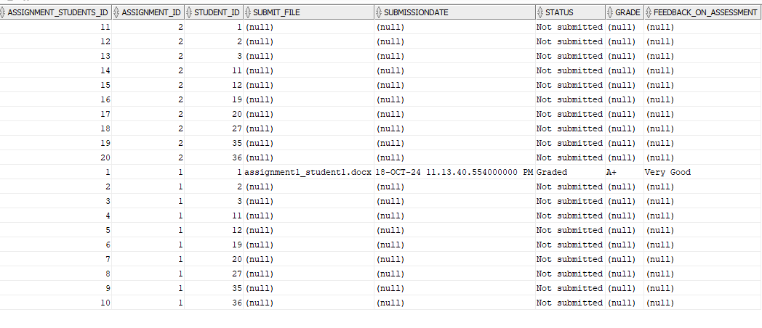

SELECT a.assignment_title, a.end_date, c.course_name, l.lesson_name

FROM assignment a INNER JOIN lessons l ON a.lesson_id = l.lesson_id

INNER JOIN courses c ON l.course_id = c.course_id

WHERE a.end_date BETWEEN SYSDATE AND SYSDATE + 7

ORDER BY a.end_date;

### **Average, Maximum, and Minimum Salaries by Department**

SELECT

d.department_name,

AVG(l.salary) AS average_salary,

MAX(l.salary) AS max_salary,

MIN(l.salary) AS min_salary

FROM departments d INNER JOIN lecturers l

ON d.department_id = l.department_id GROUP BY d.department_name;

### **Number of student enrollments**

SELECT c.course_name, COUNT(ce.student_id) AS number_of_enrollments

FROM courses c INNER JOIN course_enrollments ce ON c.course_id = ce.course_id

GROUP BY c.course_name ORDER BY number_of_enrollments DESC;

### **Update Course Enrollment for Students**

UPDATE course_enrollments SET course_id = 5 WHERE

student_id IN (SELECT student_id FROM course_enrollments WHERE course_id = 6);



### **Courses Without any enrollments**

SELECT c.* FROM courses c

LEFT JOIN course_enrollments ce ON c.course_id = ce.course_id

WHERE ce.course_id IS NULL;



### **Total number of lessons per course**

SELECT c.course_name, COUNT(l.lesson_id) AS total_lessons

FROM courses c LEFT JOIN lessons l ON c.course_id = l.course_id

GROUP BY c.course_name ORDER BY total_lessons DESC;

### **Fetch Unsubmitted Assignments for Specific Student ID**

SELECT a.student_id,a.status,ast.assignment_title,ast.assignment_fiies,ast.post_date,ast.end_date

FROM ADMIN.assignment_students a JOIN ADMIN.assignment ast on a.assignment_id = ast.assignment_id

WHERE status = 'Not submitted' AND student_id = 1 ;

### **Fetch Students Based on Name, Email, and Phone**

SELECT * FROM students WHERE

(first_name LIKE 'A%' OR last_name LIKE '%ndo')

AND email LIKE '%@gmail.com'

AND phone_number LIKE '07_%'

ORDER BY last_name, first_name;



### **View for Upcoming Assignments**

CREATE OR REPLACE VIEW upcoming_assignments AS

SELECT a.assignment_id, a.assignment_title, a.end_date, l.lesson_name, l.taught_by

FROM assignment a JOIN lessons l ON a.lesson_id = l.lesson_id

WHERE a.end_date > CURRENT_TIMESTAMP

### **Retrieve Upcoming Assignments from View**

SELECT * FROM upcoming_assignments;

### **Create View for Department Course and Lesson**

CREATE OR REPLACE VIEW department_course_lesson_stats AS SELECT

d.department_id,

d.department_name,

COUNT(DISTINCT c.course_id) AS total_courses,

COUNT(DISTINCT CASE WHEN c.status = 'Active' THEN c.course_id END) AS active_courses,

COUNT(DISTINCT CASE WHEN c.status = 'Inactive' THEN c.course_id END) AS inactive_courses,

COUNT(DISTINCT l.lesson_id) AS total_lessons,

COUNT(DISTINCT CASE WHEN l.status = 'Active' THEN l.lesson_id END) AS active_lessons,

COUNT(DISTINCT CASE WHEN l.status = 'Inactive' THEN l.lesson_id END) AS inactive_lessons

FROM departments d LEFT JOIN courses c ON d.department_id = c.department_id

LEFT JOIN lessons l ON c.course_id = l.course_id

GROUP BY d.department_id, d.department_name;

### **Retrieve department course lesson from View**

SELECT * FROM department_course_lesson_stats;

### **Combine Department and Course Information Using UNION**

SELECT department_id AS id,department_name AS name,created_at AS created_date,

NULL AS course_name,NULL AS status

FROM departments

UNION ALL

SELECT department_id AS id,NULL AS name,NULL AS created_date,

course_name AS course_name,status

FROM courses;

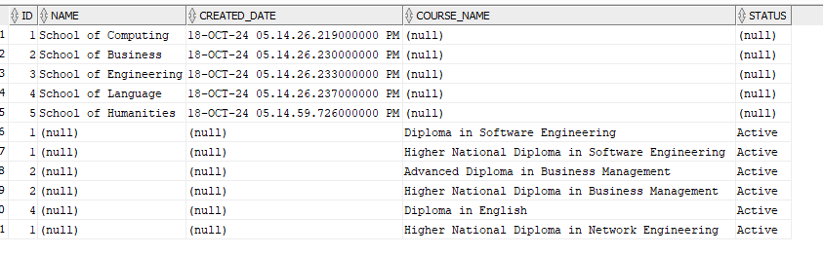

### **Create Function to Count Scheduled Lectures by lesson_id**

DECLARE

v_lecture_count NUMBER; -- Variable to hold the result from the function

BEGIN

-- Call the function and store the result in v_lecture_count

v_lecture_count := get_scheduled_lectures(2); -- Replace 1 with the desired lesson ID

-- Display the count of scheduled lectures

DBMS_OUTPUT.PUT_LINE('Number of scheduled lectures for lesson ID 1: ' || v_lecture_count);

END;

/

### **Display Count of Scheduled Lectures for a Lesson ID**

SET SERVEROUTPUT ON;

DECLARE

v_lecture_count NUMBER;

v_lesson_id NUMBER;

BEGIN

v_lesson_id := &lesson_id;

v_lecture_count := get_scheduled_lectures(v_lesson_id);

DBMS_OUTPUT.PUT_LINE('Number of scheduled lectures for lesson ID ' || v_lesson_id || ': ' || v_lecture_count);

END;

/



# Chapter 5

## **Database Administration**

# Chapter 6

## **Backup Plan**

# Chapter 7

## **Cloud Platform Deployment**